The power converter unit is essential for distributing power from the main battery to various subsystems of the MechEng Mars Rover. This guide provides detailed instructions for setting up and connecting the power converter unit.

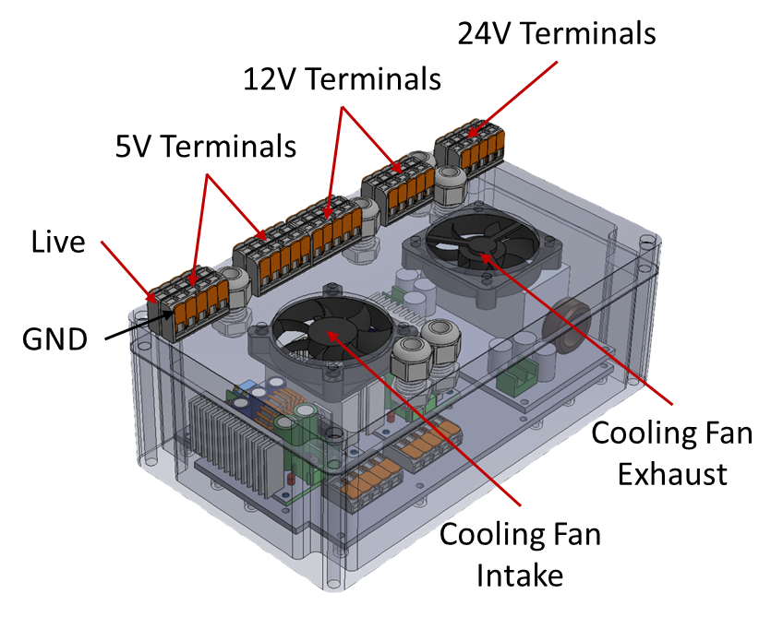

**Components**

* 300W DC-DC step-down Buck Converters (for 28V to 12V and 5V)
* 600W DC-DC step-down Buck Converter (for 28V to 24V)
* Junction box for housing converters
* WAGO connectors for power distribution
* Cooling fans for thermal management

**Power Distribution**

* Use WAGO connectors on the junction box lid to distribute power
* Provide four 24V terminals, eight 12V terminals, and eight 5V terminals

**Connection Guide**

* Connect the power source to the power converter unit input using the XT60 connector.
* Connect the subsystem electronics to the terminal, as shown in the diagram below.

